THE COUNTRY-LIFE-READERS

**FLOWERS**

**OF THE FARM**

BY ARTHUR O. COOKE

Chapter I

# INTRODUCTION

I think that some of you have been with me at Willow Farm before to-day. When we were there we went into the farmer’s

fields in early spring, and saw the men and horses at work with ploughs and harrows. A little later on we saw some of the crops sown, such as barley and turnips. In summer we were in the hay and corn-fields, and later still we saw the ricks being made.

To-day we are at Willow Farm again, and I want to show you some of the flowers that grow there. I do not mean those which Mrs. Hammond, the farmer’s wife, grows in her garden, pretty as they are. We will look rather at the wild flowers in the fields, the hedges, and by the road-side in the lane. No one sows their seed nor takes care of them in any way; yet they grow and blossom year after year, and nearly all of them are beautiful.

Before we begin to look at them we must make sure that we quite understand just what a flower is. Even those of you who live in large towns and have perhaps never been in the country, see flowers of some sort, I feel sure; you see them in shop windows and they are also often sold in the streets. You have seen wallflowers and daffodils in the spring, roses in the summer, violets in winter, as well as other kinds. You do not need to be told that these are flowers.

What about the grass on lawns, and in such places as Battersea Park and Hyde Park in London? “Oh,” you say, “that is not a flower at all – that is just grass.” Yes, it is grass, but the grass has a flower as well as a rose bush or a violet-plant. It is only because the grass is kept cut short that you do not see its flower on a lawn. If grass is not cut, or eaten by animals, it grows tall in spring; then in May or June you would see the flowers on tall straight stems which stand among the blades of grass. Many of these grass flowers are very beautiful and we will look presently at some of them in one of the farmer’s fields.

Perhaps some of you have gardens or grass plots at your own homes. If you see some dandelions in the lawn, or groundsel among the flowers or vegetables in the garden beds, you say, “Those weeds must be pulled up.” You call the Dandelion and the Groundsel weeds, but they have flowers all the same; the Dandelion is perhaps one of the loveliest yellow flowers that we have.

They are weeds certainly in your lawn or garden beds, for they ought not to be there. Weeds are plants in the wrong place. By and by, in the farmer’s fields, we shall see many pretty flowers which he calls weeds. We speak of the Nettle as a weed, and do not usually admire it; yet the Nettle has a flower, as we shall see.

Then what do you think of a tree having a flower? That is perhaps a new idea to you. Yet if you look at a Horse-chestnut tree in June you will see at once the large spikes of beautiful white flowers with which it is covered. Apple trees have a beautiful pink, or pink and white flower, and the Almond tree bears a lovely pink flower. All other trees have flowers too, but they are often small. The flowers of the Oak and the Beech are small, but, though you may not notice them, they are on the tree each spring.

Almost all plants, including large trees, have flowers – they are flowering plants. Just a few plants have no flower; ferns have none, nor have the mosses and lichens which grow on walls and rocks and on the stems of trees. Fungi, too, such as the mushroom, have no flowers. Nearly all other plants have flowers. It is by the flower or blossom that a plant is reproduced. After the flower has faded comes the fruit and seed; the seed falls into the ground or is sown, and from it springs another plant. Without the flower there would be no seed.

You see that there are rather more flowers than you had thought. Still, while we are strolling in the fields and lanes at Willow Farm, we shall look most at what are generally called flowers; we shall look at comparatively small plants in which the flower or blossom is easily noticed because it is large, or bright-colored, or sweet-scented. But while we are admiring a Daisy or a Dandelion in the spring, we must not forget that the great Oak-tree above it also has a flower of its own – we must remember that the Oak-tree also is a flowering plant.

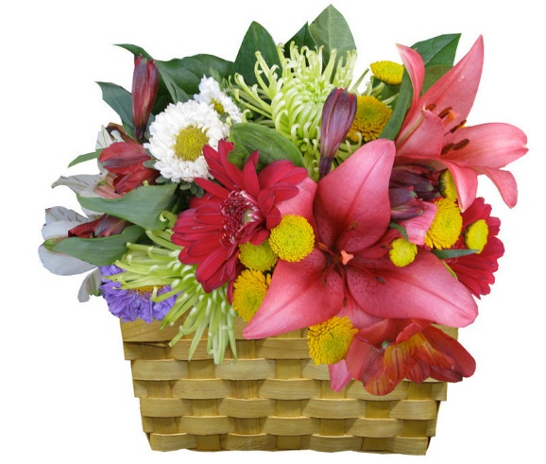

Chapter II

# IN THE COPPICE

Outside the front door of Willow Farm is a broad curving gravel drive, at the far end of which a white gate opens into the lane. On one side of this drive is a narrow strip of ground planted with flowers and shrubs, and close to the front door there is a patch of grass on which stands a large old mulberry tree.

On the other side of the drive is a lawn. Beyond that are more flowers and then the vegetable garden; further on still is a little wood or coppice of nut bushes. On this March morning we shall find some wild flowers in this little wood.

Between the vegetable garden and the wood is a low grassy bank. It is bright to-day with yellow primroses. The Primrose always blossoms early here, for the bank is sunny and is sheltered from cold winds.

I daresay most of you have seen a Primrose before to-day. Each pale-yellow blossom is made up of five petals, which are joined together forming a tube or corolla. The petals are notched or indented on the outer edge. At the center of the blossom, where the petals meet, each petal is marked with a spot of darker yellow. Each flower grows alone on a long slender stem. At the top of the stem is a kind of green tube out of which the

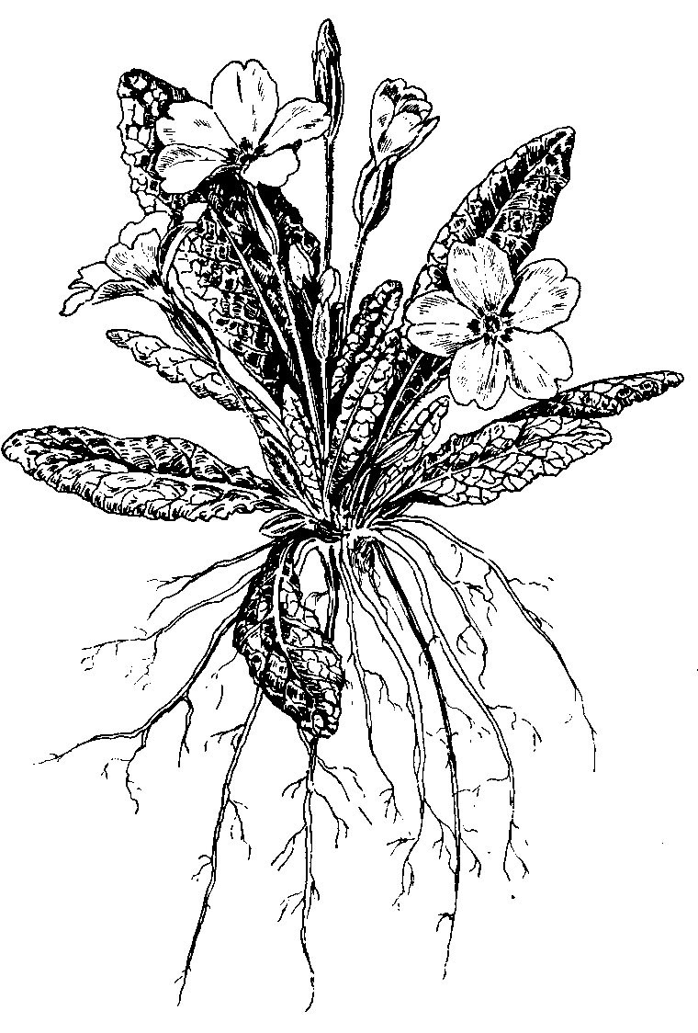yellow blossom appears. The Primrose blossoms have a scent; not strong, but very sweet and pleasant.

The leaves are called “radical” or “root” leaves. They are so called because each leaf appears to grow direct from the root. But the leaves really grow from a short stem at the top of the root – a stem so short that it does not appear above the ground at all.

Among the bushes of the coppice itself we will notice the flowers which first catch our eye – the pretty blossoms of the Wood Anemone. The whole coppice is starred with the beautiful white flowers. We pick one and see that it has six – six what? “Six petals,” you say. No, these are not petals, for the Anemone has none. They are sepals. The sepals of a plant generally enclose the blossom before it is opened, and they are usually green. In the Anemone the petals are absent; the sepals take their place and are white instead of green. Their under side is often not pure white, but is streaked with pale pink.

Several blossoms which we pick have six of these sepals. That is the usual number, but sometimes there are only five, and sometimes more than six.

The blossoms of the Anemone grow on longer and stronger stalks than those of the Primrose, and on each stalk are three leaves. These leaves grow round the stalk in a ring. Each leaf is “tri-partite” – in three parts or divisions; the edges of these divided leaves are deeply serrated. Besides the three leaves on each flower-stalk similar leaves grow from underground stems which creep along not far below the surface of the soil. Such creeping underground stems are usually called “rhizomes.”

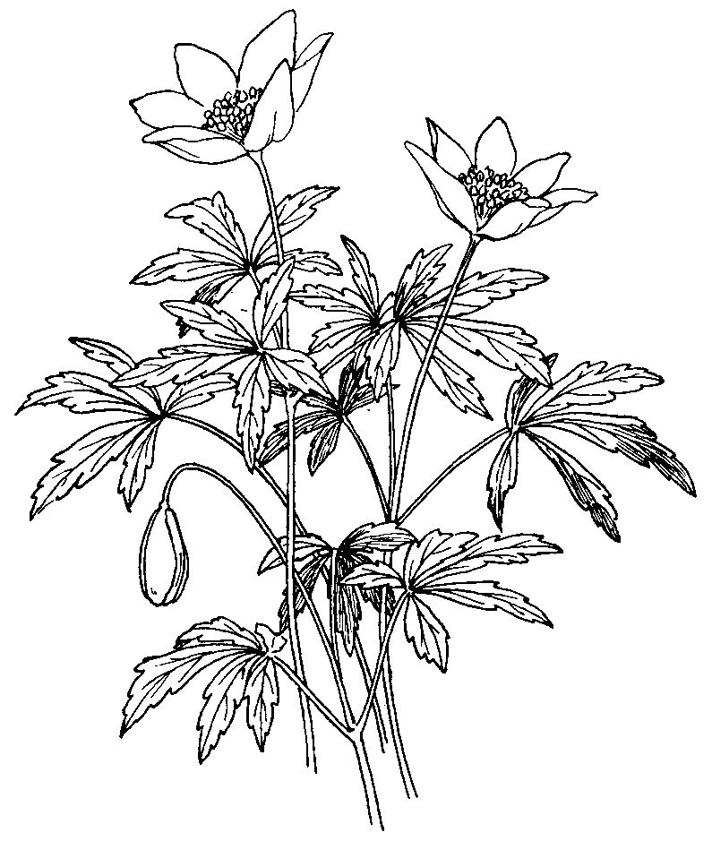At the further side of the coppice,

where a hedge separates it from the little meadow called Home Close, are Sweet Violets. We catch their fragrant scent before we see them, for the tiny flowers are half hidden among broad green leaves. Each blossom has five petals of a dark purple color; there are white Sweet Violets too, but none are growing in our little wood to-day.

At the base of the blossom – the part where it joins the stem – one of the *Anemone* petals has a little spur which points back towards the stem. The blossom is therefore said to be spurred; we may presently see other plants with spurred flowers.

There is another violet which grows wild in England – the Dog Violet. It is larger than our Sweet Violets here, but it has no scent.

While we have been examining the flowers on the ground, the nut bushes above our heads are waiting to remind us of what we said just now – that trees also have flowers. The flowers of the nut bush or hazel are easily seen, for they appear before the leaves are open. What we see to-day are often called catkins, but the name which country children give them is lambs’-tails. It is a very good name, too, for they are more like the tail of some tiny lamb than anything else.

These catkins are yellowish-white in color, and soft and almost

woolly to the touch. They hang in clusters from the hazel twigs,

and in the strong March wind which blows to-day, they shake and

flutter like the tails of lambs at play. Some of them leave a dusty powder on our fingers when we handle them; that is the pollen of the flower.

It is not where these yellow “catkins” are dancing on the twigs

to-day that the hazel nuts will appear in autumn. The nuts will grow on twigs where there are very small red flowers – something like tiny paint-brushes. These are the female flowers; they will be fertilized by the yellow pollen of the catkins, and will produce the nuts.